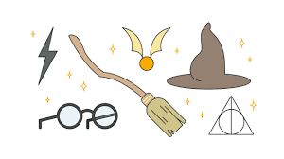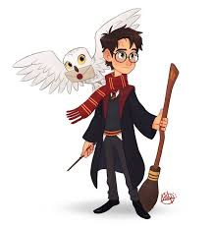**––––––**

* Choose your weekly homework from the menu below
* Homework is due back to school no later than the following Wednesday
* All activities need to be completed across the half-term
* Challenge yourself with activities *at least* once across the half-term.
* In addition, reading should be completed regularly and logged in your Planner.
* Maths and spellings will be expected to be completed weekly. (separate sheets)

Year 3 and 4Spring 2 Pick and Mix Home Learning

# **Magical Worlds**

|  |  |
| --- | --- |
| **Topic** | **English** |
| **Science**  This half term in Science, we are looking at electricity. Make a list of everything in your home that uses electricity. | Write a set of instructions on how to make a special potion. Remember to include illustrations and any safety points and warnings. |
| **Music**  Practise the songs from our performance and lines if you have any. | Create a fact file about a wizard, character or creature from any of the Harry Potter books. |
| **Design and Technology**  Draw a design for an invention that uses electricity and would make your life easier. | Write a report on how electricity changed the world. Think about what we use electricity for today and how life must have been without those things. |
| **Art**  Design a new magical sweet and label it. | If the sorting hat sorted you into one of the four houses, which one would you be put into? Explain giving three reasons why. |
| **Design and Technology**  Create top trump cards for 4 different characters from the Harry Potter books (You can do more if you want!) | Create a map of the forbidden forest in Harry Potter or any other magical and mysterious place of your choosing. |
| **Family Time**  As a family play a board game together. You might like to take a photo of this to stick into your Home Learning book. | Write a story about your first time/adventure on a broomstick. |